H.T No
Regulations:
A20

Sreenidhi Institute of Science and Technology
(An Autonomous Institution)
Code No: 8A201 Date: 18-Feb-2025 (FN)

B.Tech I-Year II- Semester External Examination, February-2025 (Supplementary)
ELECTRICAL CIRCUITS AND NETWORKS-I (EEE)

Time: 3 Hours Max.Marks:70

Note: a) No additional answer sheets will be provided.
b) All sub-parts of a question must be answered at one place only, otherwise it will not be valued.
c) Missing data can be assumed suitably.
Bloom's Cognitive Levels of Learning (BCLL)

Remember | L1 | Apply | L3 | Evaluate | L5
Understand | L2 | Analyze | L4 | Create | L6

Part - A Max.Marks:20

Answer all QUESTIONS.

 |  | BCLL | CO(s) | Marks
1 | Define i) Voltage ii) Current | L1 | CO1 | [2M]
2 | Explain graphical method to draw dual network. | L2 | CO2 | [2M]
3 | Define Relative permeability and coupling coefficient? | L1 | CO3 | [2M]
4 | Define Form factor. | L1 | CO4 | [2M]
5 | Draw the locus diagram of series RL circuit with variable R and constant L. | L1 | CO5 | [2M]
6 | State Thevenin’s and Norton’s theorems | L1 | CO6 | [2M]
7 | Define basic tie-set and give the condition to form basic tie-set. | L1 | CO2 | [2M]
8 | Write the equation of equivalent inductance for the following  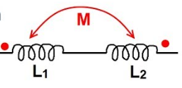 | L1 | CO4 | [2M]
9 | States the Thevenin's theorem for AC excitation with suitable diagram. | L1 | CO5 | [2M]
10 | State Milliman’s and Tellegen’s theorem. | L1 | CO6 | [2M]

Part – B Max.Marks:50
ANSWER ANY FIVE QUESTIONS. EACH QUESTION CARRIES 10 MARKS.

 |  |  | BCLL | CO(s) | Marks
11. | a) | For the bridge network shown in Figure, find the R_{ab} and i.  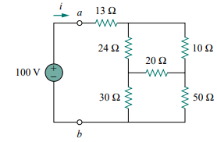 | L3 | CO1 | [5M]
 | b) | For the circuit of Figure, find the values of V₁ and V₂.  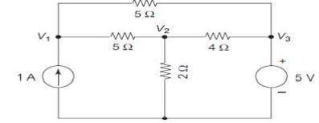 | L3 | CO1 | [5M]
12. | a) | Define incidence matrix, cutset and tieset matrix with examples. | L2 | CO2 | [5M]
 | b) | Draw the graph and write down the tieset matrix  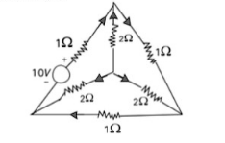 | L1 | CO2 | [5M]
13. | a) | A mild steel ring of circumference 50cm and cross-sectional area of 5cm² has a coil of 250 turns wound around it. Calculate: (i) The reluctance.  (ii) The current required to produce a flux of 700 mWb.  The relative permeability =380. | L3 | CO3 | [5M]
 | b) | Two coils connected in series-aiding fashion have a total inductance of 250 mH. When connected in a series-opposing configuration, the coils have a total inductance of 150 mH. If the inductance of one coil (L₁) is three times the other, find L₁, L₂, and M. What is the coupling coefficient? | L2 | CO3 | [5M]
14. | a) | Predict the voltage, current and power in series RC circuit using sinusoidal excitation? | L2 | CO4 | [5M]
 | b) | A saw tooth voltage as shown in figure is applied to a capacitor of  C= 30µFarad. Determine the capacitor current.  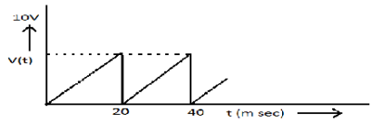 | L3 | CO4 | [5M]
15. | a) | Obtain the expression for Resonant frequency of a parallel RLC Circuit. | L3 | CO5 | [5M]
 | b) | What is the significance of Locus Diagrams? And draw the locus diagram for parallel R-L circuit with variation of various parameters. | L2 | CO5 | [5M]
16. | a) | Determine the equivalent circuit between the terminals A&B in the given network using Thevenin’s Theorem?  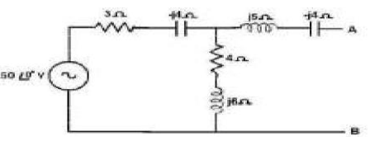 | L3 | CO6 | [5M]
 | b) | With the help of an example, explain about Millman’s theorem? | L2 | CO6 | [5M]
17. | a) | With an example explain about Kirchhoff’s laws? | L2 | CO1 | [4M]
 | b) | Explain the concept of duality? | L2 | CO2 | [3M]
 | c) | Derive the expression for co-efficient of coupling helps in identifying how strongly two coils are coupled? | L2 | CO3 | [3M]
18. | a) | Explain the concept of susceptance and admittance offered by R, L, C parameters. | L2 | CO4 | [4M]
 | b) | Draw the Tank circuit and derive the equation for resonant frequency. | L1 | CO5 | [3M]
 | c) | With the help of an example, explain about Compensation theorem. | L2 | CO6 | [3M]

-- 00 -- 00 –

